**7. Implement program for decomposing time series data into trend and seasonality.**

**AIM:**

Implement program for decomposing time series data into trends and seasonality.

**PROCEDURE:**

**1.Import the necessary libraries:**

import pandas as pd

import matplotlib.pyplot as plt

from statsmodels.tsa.seasonal import seasonal_decompose

**2.Load dataset**

file_path = 'autism_screening.csv' # Update the filename if needed

df = pd.read_csv(file_path)

**3.Simulate a time-series index (assuming daily records)**

df['Date'] = pd.date_range(start='2024-01-01', periods=len(df), freq='D')

df.set_index('Date', inplace=True)

**4. Check for and handle zero/negative values**

if (series <= 0).any():

min_value = series.min()# Shift the series to be positive

if min_value <= 0:

series = series + abs(min_value) + 1 # Add 1 to ensure all values are strictly positive

**5. Perform seasonal decomposition// Multiplicative**

result = seasonal_decompose(series, model='multiplicative', period=period)

**6.Plot results**

plt.figure(figsize=(10, 8))

plt.subplot(3, 1, 1)

plt.plot(series, label='Original')

plt.legend()

plt.subplot(3, 1, 2)

plt.plot(result.trend, label='Trend', color='orange')

plt.legend()

plt.subplot(3, 1, 3)

plt.plot(result.seasonal, label='Seasonality', color='green')

plt.legend()

plt.tight_layout()

**7.Perform seasonal decomposition using the 'additive' model**

result = seasonal_decompose(series, model='additive', period=period) # Changed to 'additive'

**8.Plot results**

plt.figure(figsize=(10, 8))

plt.subplot(3, 1, 1)

plt.plot(series, label='Original')

plt.legend()

plt.subplot(3, 1, 2)

plt.plot(result.trend, label='Trend', color='orange')

plt.legend()

plt.subplot(3, 1, 3)

plt.plot(result.seasonal, label='Seasonality', color='green')

plt.legend()

plt.tight_layout()

plt.show()

**OUTPUT :Multiplicative decomposition and additive decomposition**

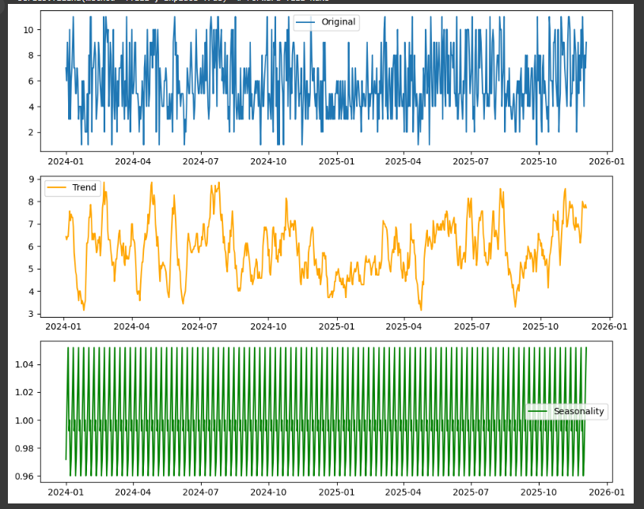

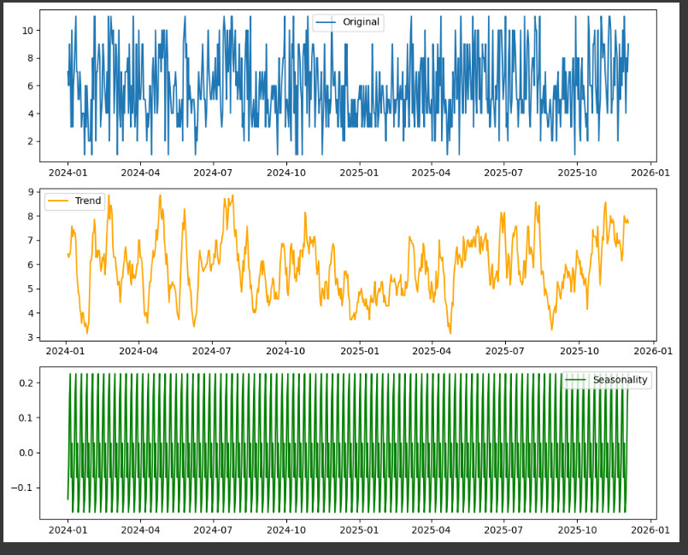

**RESULT:**

Implement program for decomposing time series data into trends and seasonality on the autism screening dataset has been implemented successfully.